Report to |  | On
Cabinet |  | Wednesday, 14 July 2021
Title |  |  |  | Portfolio Holder |  |  | Report of
South Ribble Extra Care Scheme – West Paddock |  |  |  | Cabinet Member (Finance, Property and Assets) |  |  | Director of Commercial

Is this report confidential? | No

Purpose of the Report
- To present 3 options for the proposed extra care scheme at West Paddock supported by financial models.

- To seek approval of a preferred delivery option to enable the scheme design to be developed and a more detailed project budget prepared.

Recommendations
- To approve the progression of design option 3 outlined in this report.

- To note that £200k of the allocated £10 million budget will be drawn upon to deliver the next stage of the design (RIBA Stage 2 and 3) and contractor procurement process.

- To note the current estimated project cost to deliver the 72 unit scheme is £14.260 million.

- To acknowledge that the further design works set out in paragraph 4 are required to verify the projected project cost of £14,260 million, and that further updates on the costs will be brought back when the next stage of design work has been progressed.

Reasons for recommendations
- The recommendations will enable the progression of the Council’s Corporate Strategy objective to deliver affordable housing within the borough with, the delivery of a 72-bed development.

- The development of the design work will enable a more detailed project budget to be prepared and progression of the project will support the progression of a funding bid with Homes England through their affordable homes programme.

- To acknowledge that a further detailed design and updated budget will be presented for approval to Members at Executive Cabinet on 15 September 2021.

Other options considered and rejected
- To deliver a smaller scheme of 50 units. The estimated construction costs of this scheme would align with the currently allocated capital budget of £10 million. This option has been rejected as it would be beneficial to maximise the development site and deliver as many units as possible (whilst maintaining adequate public open space for the community). This will address the demand for extra care and reduce the need for alternative sites in the future. By progressing a larger development there will be efficiency savings for the construction and the future operation of a single extra care facility.
- Delivery of a smaller scheme would not provide maximum opportunity to meet the policy objective for increasing affordable rents.

Executive summary
- The Council’s Corporate Strategy includes the ambition to deliver additional Council owned affordable housing within the borough.

- This report presents 3 options to members that will deliver 72 units of additional affordable housing that will support residents aged 55 or over that require affordable and extra care housing.

- Tenders were invited via the Chest for Architects to bid for the works up to RIBA Stage 3. 20 architect bids were received, and the contract was awarded to Norr Architects who provided the most economically advantageous tender.

- Five cost consultants were invited to provide support to assess the cost of the development and develop a business case. Four tenders were received with the contract being awarded to SDA Consulting.

- The report presents the masterplan options that have been developed for the site. The supporting financial models for the preferred masterplan are provided to demonstrate the revenue return for the scheme.

Corporate outcomes
- The report relates to the following corporate priorities: (tick all those applicable):

An exemplary council |  | Thriving communities
A fair local economy that works for everyone |  | Good homes, green spaces, healthy places

Background to the report
- The ambition to deliver Council owned affordable housing is outlined in the administration’s Corporate Strategy.

- On 16 September 2020 Cabinet Members approved:
  - that the site for the new extra care facility would be the West Paddock site
  - to approve the appointment of an appropriate consultant to undertake feasibility studies and develop a business case, following the progressionof the RIBA stage 2 design
  - a £50,000 budget to undertake a feasibility study on developing an extra care scheme at West Paddock.

Master planning

- The architect was tasked with completing RIBA stage 1 of the design process which involved developing three masterplan options that considered the site and surrounding constraints. This included but is not limited to:
- Connectivity to local amenities.
- Development access that considers the existing surrounding highway infrastructure.
- A scheme that avoids the removal of any trees;
- At least 70 apartments with a 90% 1 bed and 10% 2 bed split;
- Inclusion of a community café and hair salon within the scheme;
- Consideration of the orientation of the building to maximise opportunities for renewables such as PV panels;
- Consideration on maintain c
- A balcony on each apartment on the first and second floors;
- Apartment distances to communal areas;
- Internal and external security;
- The topography of the site.
- To achieve BREEAM ‘very good’ status.

- Each of the masterplan plan options within the draft stage 1 report presented at Appendix 1 allow for the following:
- 64 1 bed apartments (51m2 GIFA);
- 8 2 bed apartments (68m2 GIFA);
- 1 guest apartment;
- Main residents lounge;
- Scooter store;
- A community café;
- A hairdressers

- Each masterplan option is presented below with a summary of the pro and cons for each.
Option 1 – A linear three storey development with a frontage on to West Paddock.

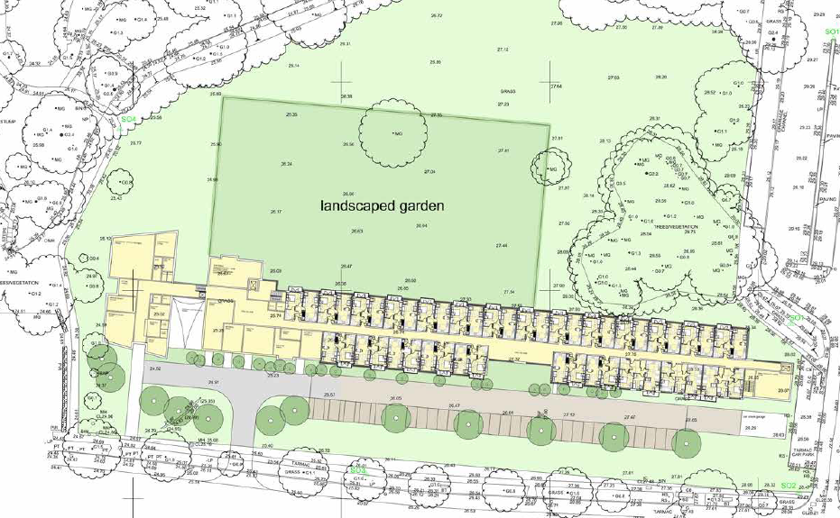

PROS | CONS
Simple configuration. | Heavy massing to front of west paddock opposite existing residential properties.
Stacked apartments will reduce complexity of structural design and build costs | Access to landscaped and greenspace more restricted for residents at the front of the building
Minimal circulation space. | Long walking distances for apartments furthest away from the communal space.

Community facilities to end of extra care development reduces required security measures.

Extra Care reception close to community facilities will aid with operational functionality

Option 2 – T-shaped Three Storey Development

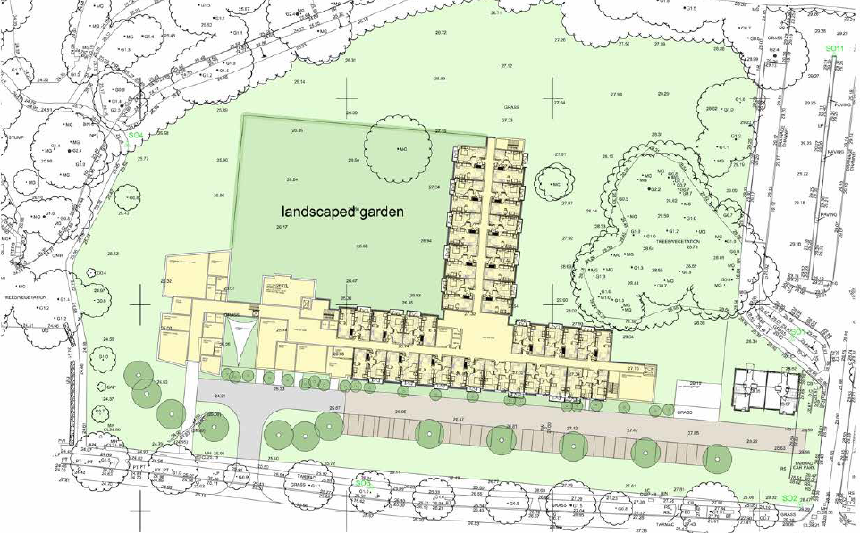
PROS | CONS
Stacked apartments will reduce complexity of structural design and build costs | T design prevents all wings from view of landscaped garden.
Responds to existing tree line | Greater circulation space
Reduction in apartments is straightforward if the layout is cost prohibitive | Long walking distances for apartments furthest away from the communal space.
Easy access to community facilities along preferential pedestrian route | Breaks up green space with built development

Community facilities to end of extra care development reduces required security measures.

Extra Care reception close to community facilities will aid with operational functionality

South facing roof space for renewables

Space allowance for two individual bungalows

Option 3 – L-Shaped 3 Storey Development

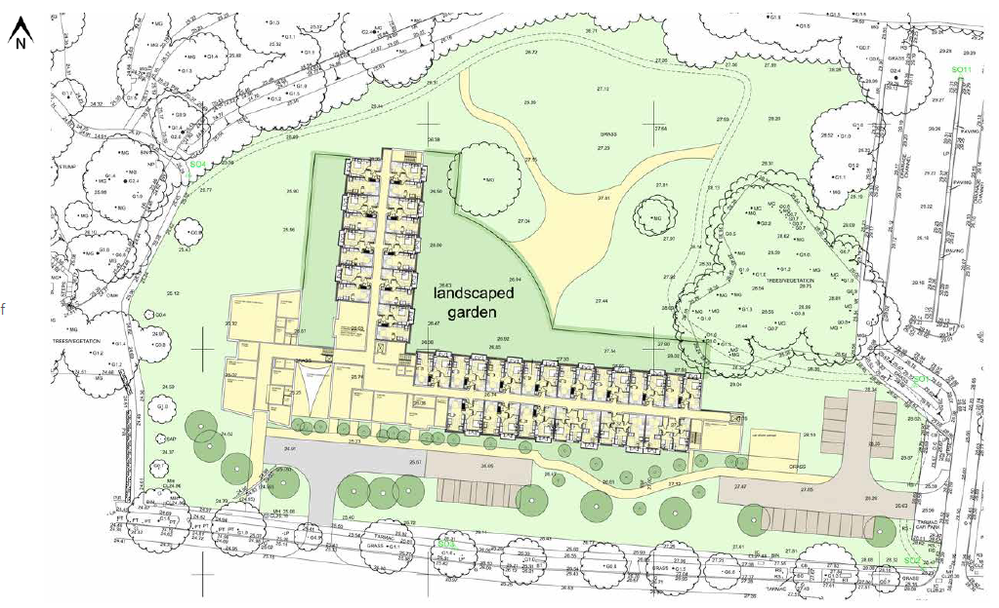
PROS | CONS
Stacked apartments will reduce complexity of structural design and build costs | Delivery cost exceeds the capital budget of £10 million.
Reduction in apartments is straightforward if the layout is cost prohibitive | L design prevents all wings from view of landscaped garden.

Walking distance from apartment to communal areas reduced.

Easy access to community facilities along preferential pedestrian route

Efficient operational space

Community facilities to end of extra care development reduces required security measures.

South facing roof space for renewables

Space allowance for two individual bungalows

Opportunity for residents scooters to be stored outside the ground floor apartments.

Early thoughts on the fabric of the building is to use traditional brickwork for the extra care element with a pitched roof. The communal space would be a more modern style structure with a curved roof.

Financial
£14m (72 apartment) Extra Care Facility

The estimated build costs to deliver the option 3 72 bed assisted living scheme has been calculated. The breakdown is included at Appendix 2. The total estimated cost to deliver the scheme is £14,260,911, £198,068 per unit.

A financial model has been developed for this development scheme which makes the following assumptions:
- The income and expenditure assumptions are based on Primrose Gardens Extra Care (Chorley Council’s extra care facility).
- The running costs overall percentage of 55% is in line with the running costs for Primrose Gardens in 20/21.
- The rent charges are the same as Primrose Gardens Extra Care. It is acknowledged that these will require a review to ensure they are suitable for the South Ribble extra care scheme.
- Homes England funding is assumed at £60k per unit. This is what was achieved for the Primrose Gardens Extra Care scheme. This is assumed to be the upper limit of funding.
- Section 106 funding of £2m is included in the capital programme
- Public Works Loan Board Borrowing at a rate of 2.09%
- 50 year borrowing period.
- 95% occupancy at year 2 onwards, this is based on occupancy rates at Primrose Gardens.
- Annual inflation of rents and expenditure of 1% per annum

- On the basis of the above, the optimum financial model is shown below. Full details are shown in Appendix 3.
Build Cost £14m, Occupancy 95%
 | £
Total Cost | 14,260,911
Grant - Homes England | (4,320,000)
Section 106 Funding | (2,000,000)
Net Cost (Borrowing) | £7,940,911

 | 2022/23 | 2023/24 | 2024/25 | 2025/26 | 2026/27 | 2027/28 | 2028/29 | 2029/30 | 2030/31 | 2031/32
Occupancy |  | 50% | 95% | 95% | 95% | 95% | 95% | 95% | 95% | 95%
Income - Assisted Living |  | (375,803) | (721,166) | (728,377) | (735,661) | (743,018) | (750,448) | (757,952) | (765,532) | (773,187)
Income - Café |  |  | (10,000) | (10,000) | (10,000) | (10,000) | (10,000) | (10,000) | (10,000) | (10,000)
Income - Hairdressers |  |  | (1,000) | (1,000) | (1,000) | (1,000) | (1,000) | (1,000) | (1,000) | (1,000)
Running Costs |  | 449,419 | 453,913 | 458,452 | 463,037 | 467,667 | 472,344 | 477,067 | 481,838 | 486,656
Borrowing |  | 165,491 | 256,751 | 256,753 | 256,756 | 256,757 | 256,756 | 256,752 | 256,755 | 256,753
 | 0 | 239,107 | (21,501) | (24,171) | (26,867) | (29,593) | (32,347) | (35,132) | (37,938) | (40,777)

- The 72 unit scheme would provide a break-even position at 92% occupancy

- The construction costs have been benchmarked against the Tatton Gardens extra care scheme which is currently under development. The costs have been developed assuming a start in August 2022, which will consider any reported construction cost increase trends. It is noted that as a result of Brexit and Covid the construction industry is very buoyant. The delay caused by Covid in the manufacturing of materials and the availability of materials from Europe is currently impacting on the availability of materials. It should be noted if the construction costs increase beyond the reported trends the reported revenue will be affected. It is important to note that the costs provided are a desk top exercise and true final costs will be established through a competitive tender exercise to appoint a contractor to deliver the scheme.

- Whilst the report sets out a 72 bed unit that has been designed considering the available space on the site and any constraints, it is recognised that the estimated cost to deliver this scheme does exceed the approved capital budget. The options that could be implemented to bring the scheme in line with the capital budget are set out below.

£10m (50 apartment) Extra Care Facility
- It is acknowledged that the capital programme currently makes allowance for a £10 million budget made up of the following:

- £3 million – Homes England funding;
- £2 million – S106 contributions;
- £5 million borrowing.

- To achieve this budget the scale of the scheme would have to be reduced. For the purposes of this report the number of extra units have been reduced on a pro rata basis against the cost per unit. To deliver the scheme within £10 million the number of units would have to be reduced 50 units.

- A finance model has been produced for 50 units with a £10 million build cost. The assumptions are as follows:

- The income and expenditure assumptions are based on Primrose Gardens Extra Care (Chorley Councils extra care facility).
- The running costs overall percentage of 55% is in line with the running costs for Primrose Gardens in 20/21.
- The rent charges are the same as Primrose Gardens Extra Care. It is acknowledged that these will require a review to ensure they are suitable for the South Ribble extra care scheme.
- Homes England funding is assumed at £3 million (£60k per unit). This is assumed to be the upper limit of funding.
- Section 106 funding of £2m is included in the capital programme
- Public Works Loan Board Borrowing at a rate of 2.09%
- 50 year borrowing period.
- 95% occupancy at year 2 within the extra care, this is based on occupancy rates at Primrose Gardens.
- Annual inflation of rents and expenditure 1% per annum

- The financial model is presented below

Build Cost £10m, Occupancy 95%
 | £
Total Cost | 9,903,400
Grant - Homes England | (3,000,000)
Section 106 Funding | (2,000,000)
Net Cost | £4,903,400
 | 2022/23 | 2023/24 | 2024/25 | 2025/26 | 2026/27 | 2027/28 | 2028/29 | 2029/30 | 2030/31 | 2031/32
Occupancy |  | 50% | 95% | 95% | 95% | 95% | 95% | 95% | 95% | 95%
Income - Assisted Living |  | (261,322) | (501,476) | (506,491) | (511,556) | (516,672) | (521,838) | (527,057) | (532,327) | (537,651)
Income - Café |  |  | (10,000) | (10,000) | (10,000) | (10,000) | (10,000) | (10,000) | (10,000) | (10,000)
Income - Hairdressers |  |  | (1,000) | (1,000) | (1,000) | (1,000) | (1,000) | (1,000) | (1,000) | (1,000)
Running Costs |  | 312,479 | 315,604 | 318,760 | 321,947 | 325,167 | 328,418 | 331,703 | 335,020 | 338,370
Borrowing |  | 102,188 | 158,544 | 158,545 | 158,541 | 158,541 | 158,544 | 158,541 | 158,539 | 158,540
 | 0 | 153,345 | (38,329) | (40,186) | (42,068) | (43,964) | (45,876) | (47,813) | (49,768) | (51,741)

- The 50 unit scheme would provide a break-even position at 88% occupancy.
- Whilst the reduced 50 unit scheme offers a better revenue return when compared to the 75 bed unit scheme it should be noted that the costs are subject to review as the reduction in build may increase the overall build cost due to economies of scale. The risk against increased construction costs remains the same as highlighted in paragraph 28.

- The proposed West Paddock site benefits from a development area that can accommodate the larger scheme, whilst maintaining a good proportion of open space for the local community. There are benefits to delivering a larger scheme which will address the identified need for extra care housing. Whilst the cost is greater there will be an efficiency saving delivering more units on one site saving the need to identify a second site and incur more development costs.

Other Funding Options

Officers continue to review funding opportunities; the following funding bids have been submitted to date.
Funding | Value | Outcome
Land Release Funding (One Public Estate Round 8) |  | Unsuccessful
Brownfield Land Release Fund (BLRF) | £1,310,000 | Announcement expected Summer 2021

Next Steps and Programme

The next steps are summarised below.
Activity | Milestone
Finalise Masterplan Options and Financial Appraisals | 25 June 2021
Presentation at Senior Management Meeting | 30 June 2021
Presentation at Leader Brief | 05 July 2021
Presentation at Executive Cabinet | 14 July 2021
Council approval of scheme budget | 21 July 2021
Appointment of wider technical team to progress stage 2 design | 28 July 2021
Executive Cabinet to agree procurement strategy for Contractor and stage 2 design | 15 September 2021
Progress the procurement of the Contractor partner | 16 September 2021
Tender development opportunity | 18 October 2021
Appoint Contractor to progress stage 3 design | 03 December 2021

- A programme is included at Appendix 4.

Risk
- Key risks relating to the delivery of the scheme are identified below.

Risk | Mitigating Measures
The cost of construction increases more than what has been predicted in the financial model increasing the overall scheme cost | - Continue to monitor market trends and update the model accordingly;  - Explore additional funding opportunities;  - Ensure the scheme is designed considered the cost of materials.
Assumed homes England Grant funding amount not achieved | Early engagement with Homes England to confirm grant.
Availability of materials due to Brexit and Covid | Progress the design reviewing the material availability and incorporate available materials into the design
Lancashire County Council Highways and planning do not support the scheme | Early engagement with the Officer to discuss the scheme concept.
Competitive tendering exercise for procurement of a contractor exceeds the estimated costs | Set a budget target during the tendering exercise that is reflective of the cost estimates

Equality and diversity
- To be addressed at a later date,

Air quality implications
- An air quality impact assessment will be undertaken as part of the ongoing design process.

Comments of the Statutory Finance Officer
- The net income from both models are broadly similar. If the larger capital project is approved a request will be made to Full Council to increase the project budget.

Comments of the Monitoring Officer
- The recommendations are necessary to enable members to make an informed decision on the best option for the development of the site. It is appropriate for members to identify a preferred option to enable the design work to be undertaken. The design work will then inform future decisions on budget and form of delivery.
- As the design work can be used for the reduced scheme, should members later prefer the 50 bed option, the design work can be repurposed for this use.

Background documents
Cabinet Report – 16.09.20

Appendices

Appendix 1 – Stage 1 Report
Appendix 2 – Construction Cost Estimate (confidential)
Appendix 3 – Financial Model Summary (confidential)
Appendix 4 -- Programme

Mark Lester
Director of Commercial

Report Author: | Email: | Telephone: | Date:
Rachel Salter (Service Lead (Development and Business)) | rachel.salter@southribble.gov.uk | 01257 515 332 | 01.07.21

